Sophie Eppler - CV
Sophie Eppler

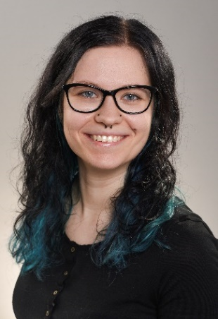
06.02.1997, Freudenstadt
Institute of Experimental Cellular Therapy
University Hospital Essen
Hufelandstrasse 55
45122 Essen, Germany
Phone: +49-201-723 4593
Fax: +49-201-723 4546
Email: mariesophie.eppler@uk-essen.de
Technician

PROFESSIONAL EXPERIENCE
Since 12/2021 Technician at the Institute for Experimental Cellular Therapy, University
Hospitel Essen

EDUCATIONAL BACKGROUND
09/2017 | - | 07/2021 | Bachelor of Engineering Environmental monitoring and forensic chemistry at the University Hamm- Lippstadt
09/2013 | - | 07/2016 | General qualification for University entrance at the BSZ für Gastgewerbe Ernst Lößnitzer, vocational high school, Dresden

RESEARCH EXPERIENCE
10/2020 | - | 02/2021 | Bachelor Thesis at the University Hamm- Lippstadt  Titel: “Identification of three food dyes on dyed eggshells by UHPLC-DAD-MS/MS.”

